コロナウイルス感染防止

のためにお聞きします

[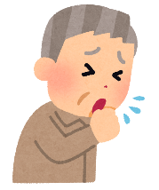](https://www.google.co.jp/url?sa=i&url=https%3A%2F%2Fwww.irasutoya.com%2F2016%2F09%2Fblog-post_821.html&psig=AOvVaw2bFvqLnw0XMJhxx-Yln6Ag&ust=1593762238337000&source=images&cd=vfe&ved=0CAIQjRxqFwoTCMjy-ZWJruoCFQAAAAAdAAAAABAD)

咳・鼻水

頭痛・だるさ

３７．５℃以上のお熱

[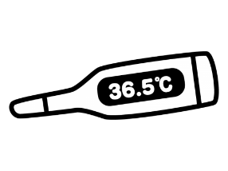](https://www.google.co.jp/url?sa=i&url=https%3A%2F%2Fwww.monopot-illust.com%2Fillust%2F4345&psig=AOvVaw3h0pbYkWrW_ajUKXj_oGXl&ust=1593762197276000&source=images&cd=vfe&ved=0CAIQjRxqFwoTCJiSkP-IruoCFQAAAAAdAAAAABAD)

[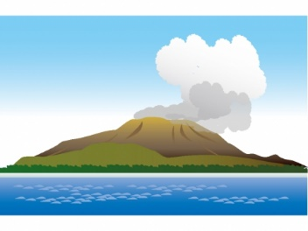](https://www.google.co.jp/url?sa=i&url=https%3A%2F%2Fillust-imt.jp%2Farchives%2F006893%2F&psig=AOvVaw2XzcKWRoKQI-Q7n8GGP7Qh&ust=1593762391569000&source=images&cd=vfe&ved=0CAIQjRxqFwoTCMiarPCJruoCFQAAAAAdAAAAABAR)

鹿児島県外の  
人との接触

２週間以内に  
県外に出た

ご家族の

体調不良

３密の場所に

出かけた

[](https://www.google.co.jp/url?sa=i&url=https%3A%2F%2Fillalet.com%2Fmiddle-aged-man-sick-condition%2F&psig=AOvVaw0CJ_inuntF9zqXcNTUzd6m&ust=1593762847562000&source=images&cd=vfe&ved=0CAIQjRxqFwoTCKDhjbuLruoCFQAAAAAdAAAAABAD)

[](https://www.google.co.jp/imgres?imgurl=https%3A%2F%2Fillustknock.com%2Fwp-content%2Fuploads%2F2020%2F04%2F0600-no-crowded-places-pictogram.png&imgrefurl=https%3A%2F%2Fillustknock.com%2F2020%2F04%2F29%2F0600-no-crowded-places-pictogram%2F&tbnid=6qkgeeCdKM0DgM&vet=12ahUKEwiD0PyNi67qAhUUgMYKHZvyDEEQMyhAegQIARBo..i&docid=SXroDOdypbfisM&w=680&h=490&itg=1&q=%E5%AF%86%E9%9B%86%E3%82%A4%E3%83%A9%E3%82%B9%E3%83%88&ved=2ahUKEwiD0PyNi67qAhUUgMYKHZvyDEEQMyhAegQIARBo)

ご協力ありがとうございます